

**HITESH JOSHI**

21/10/JC/028

MCA

JAWAHARLAL NEHRU UNIVERSITY

**C PROGRAMMING PROJECT**

***SNAKE AND LADDERS***

Submitted to: Dr. Piyush Pratap Singh

Source Code

*#include<stdio.h>*

*#include <time.h>*

*#include <dos.h>*

*#include <stdlib.h>*

*void winner(int*,int ,int,char []);*

*void winner(int *a,int i,int temp,char name[10])*

*{*

*if(*a==100)*

*{*

*printf("\n\n\t\t\t\t!!!!!!!!! %s IS THE WINNER !!!!!!!",name);*

*exit(0);*

*return ;*

*}*

*else if (*a>100)*

*{*

*\*a=temp;*

*return;*

*}*

*else*

*return;*

*}*

*int main()*

*{*

*int arr[100],p; //p-no of players*

*//----------------------------------- LADDERS, SNAKES, AND VALUES OF BLOCK ---------------------------*

*for (int i = 1; i < 101; i++)*

*{*

*if (i==4)*

*arr[i]=45;*

*else if (i==6)*

*arr[i]=25;*

*else if (i==32)*

*arr[i]=5;*

*else if (i==40)*

*arr[i]=77;*

*else if (i==43)*

*arr[i]=17;*

*else if (i==47)*

*arr[i]=66;*

*else if (i==50)*

*arr[i]=93;*

*else if (i==52)*

*arr[i]=11;*

*else if (i==57)*

*arr[i]=24;*

*else if (i==61)*

*arr[i]=98;*

*else if (i==62)*

*arr[i]=22;*

*else if (i==68)*

*arr[i]=87;*

*else if (i==91)*

*arr[i]=51;*

*else if (i==95)*

*arr[i]=76;*

*else if (i==99)*

*arr[i]=10;*

*else*

*arr[i]=i;*

*}*

*// ----------------------------------------- SHOWING BOARD -----------------------------------------------------*

*for (int i = 100; i >0 ; i--)*

*{*

*if (i%10==0)*

*printf("\n");*

*printf("| %4d |",arr[i] ) ;*

*}*

*// ---------------------------------------------- PLAYERS -----------------------------------------------------*

*printf("\n \n \n Enter the number of players : ");*

*scanf("%d",&p);*

*printf("\n There are %d players : ", p);*

*int players[p]; // players - store place of player after every throw*

*char playname[p][10]; // playname - store name of player*

*for (int i = 1; i <= p; i++)*

*{*

*printf("\n Enter the name of player %d : ",i);*

*scanf("%s",&playname[i]);*

*}*

*printf("\n\n Players are at place : ");*

*for (int i = 1; i <= p; i++)*

*{*

*players[i]=0;*

*printf("%d ",players[i]);*

*}*

*//----------------------------------------- DICE THROW-------------------------------------------------------------*

*srand(time(0)); // Initialize random number generator.*

*do*

*{*

*int i=1;*

*while (i<=p)*

*{*

*int dice;*

*char t;*

*sleep(1);*

*printf("\n \t\t\t\t\t%s will throw dice ", playname[i]);*

*printf("\n......CLICK ENTER TO THROW : ");*

*scanf("%c",&t);*

*dice=(rand() % 6) + 1;*

*printf("\n Outcome at dice is: %d ",dice);*

*int temp=players[i];*

*if((players[i]==0)&&(dice==6))*

*players[i]=1;*

*else if (players[i]>0)*

*players[i]+=dice;*

*else*

*printf("\n XXXXXXXXXXXXXXXXXXXXXXXXXXX NEED 6 ASAP TO START YOUR GAME XXXXXXXXXXXXXXXXXXXXXXXXXXXXXXXX \n");*

*winner(&players[i],i,temp,playname[i]); //check if someone won the game*

*printf("\n%s is at : %d \n \n ",playname[i],players[i]);*

*if((players[i]!=0) && (players[i]<arr[players[i]]))*

*{*

*printf ("\n // // // // // // // // // // // // // // // LADDER ENCOUNTERED // // // // // // // // // // // // // // // //");*

*players[i]=arr[players[i]];*

*printf("\n%s is at : %d \n \n ",playname[i],players[i]);*

*}*

*if((players[i]!=0) && (players[i]>arr[players[i]]))*

*{*

*printf ("\n~ ~ ~ ~ ~ ~ ~ ~ ~ ~ ~ ~ ~ ~ ~ ~ ~ ~ ~ ~ ~ ~ ~ ~SNAKE ENCOUNTERED~ ~ ~ ~ ~ ~ ~ ~ ~ ~ ~ ~ ~ ~ ~ ~ ~ ~ ~ ~ ~ ~ ~ ~");*

*players[i]=arr[players[i]];*

*printf("\n%s is at : %d \n \n ",playname[i],players[i]);*

*}*

*i++;*

*}*

*printf("\n \t\t\t\t\tPlayers are at place : ");*

*for (int i = 1; i <= p; i++)*

*{*

*printf("%d ",players[i]);*

*}*

*printf("\n\n");*

*}while (1);*

*return 0;*

*}*

OUTPUTS

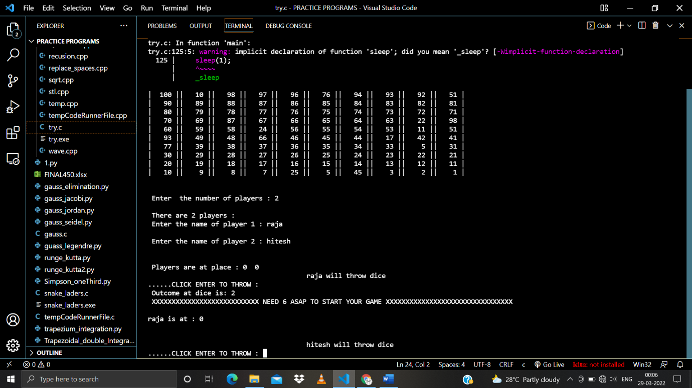

Showing board, number of players, and their names

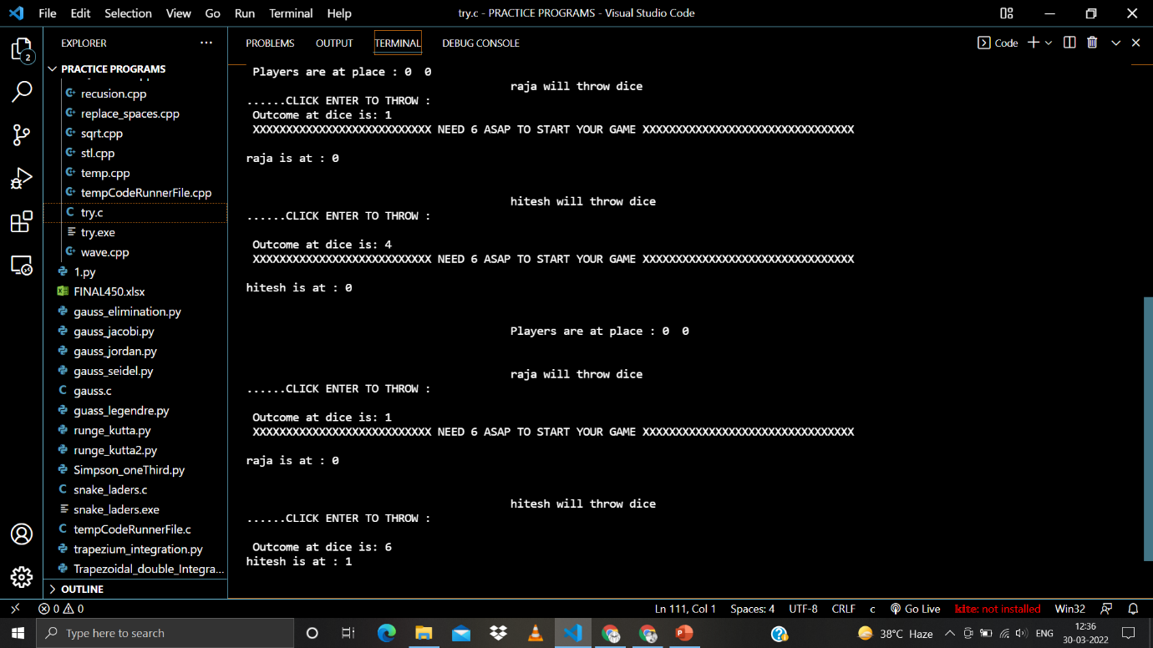

Players will start at 0 and will need 6 to start the game

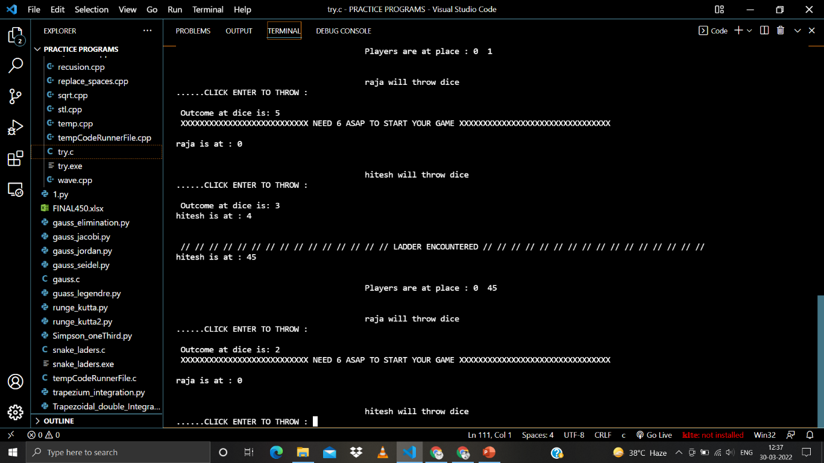

Ladder encountered

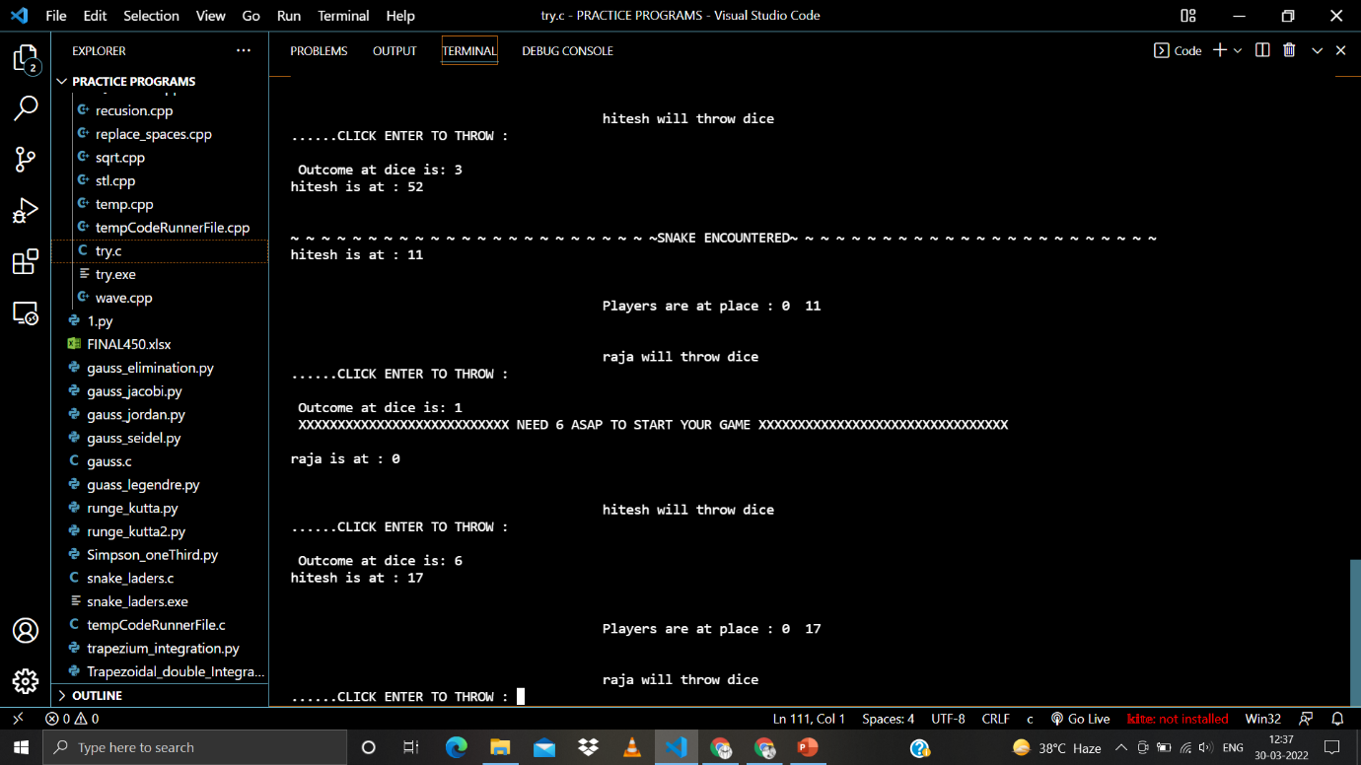

Snake encountered

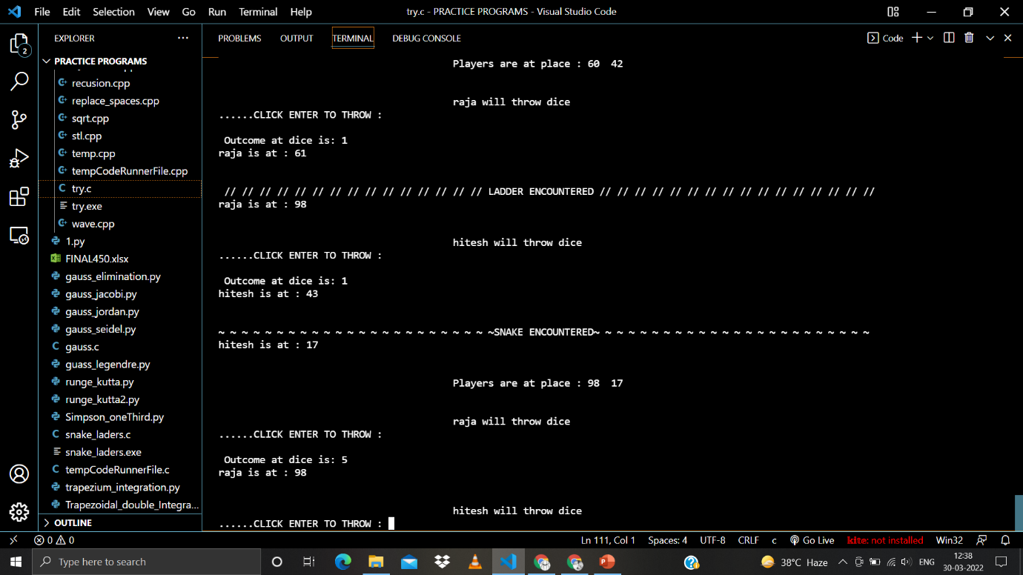

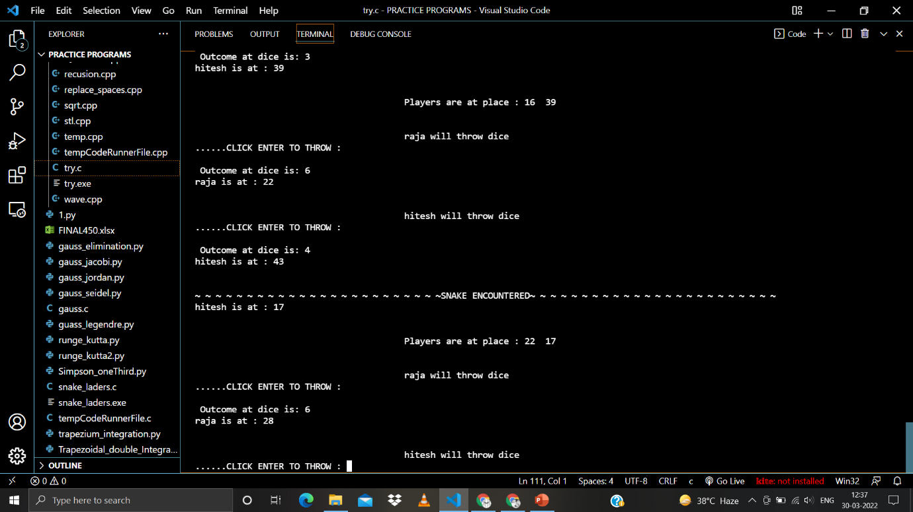

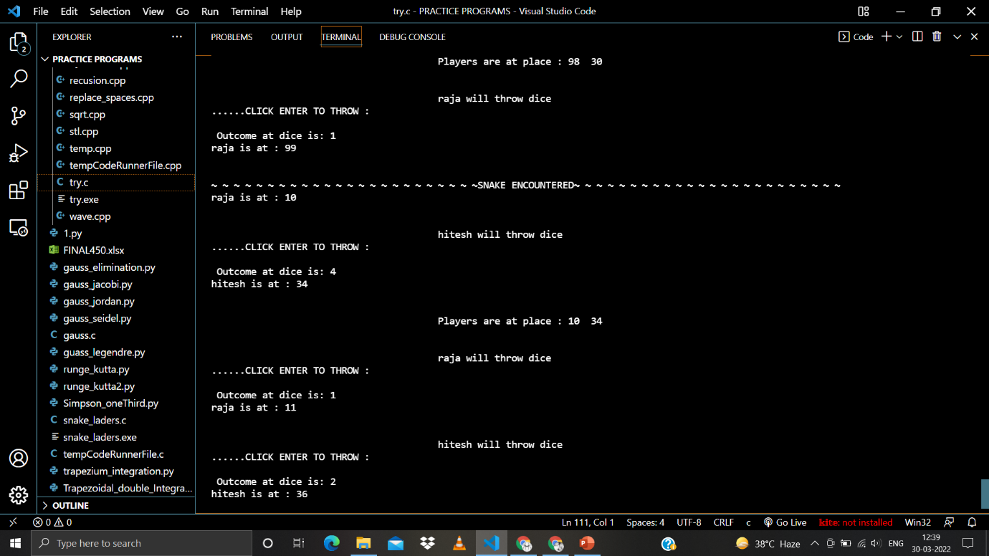

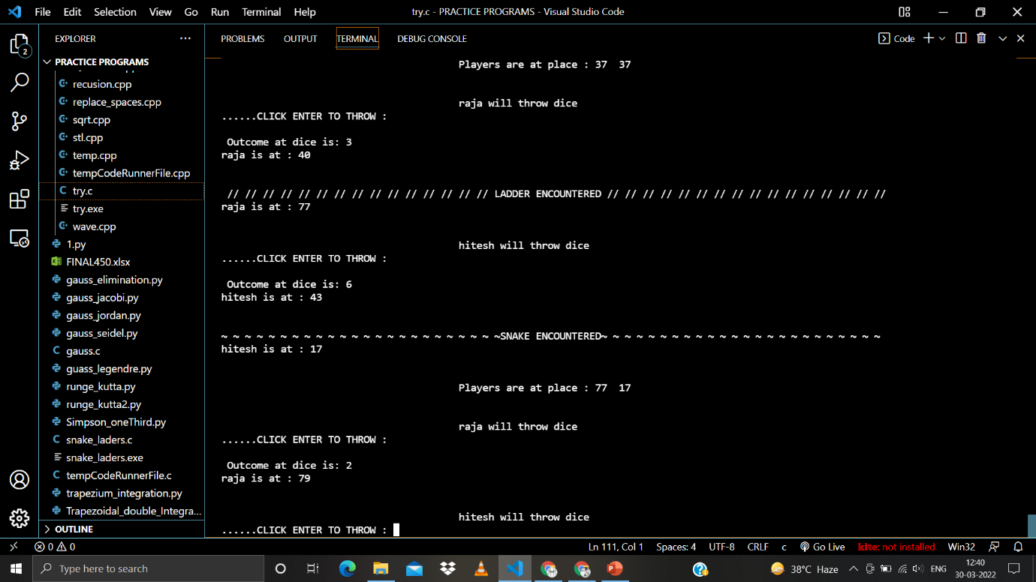

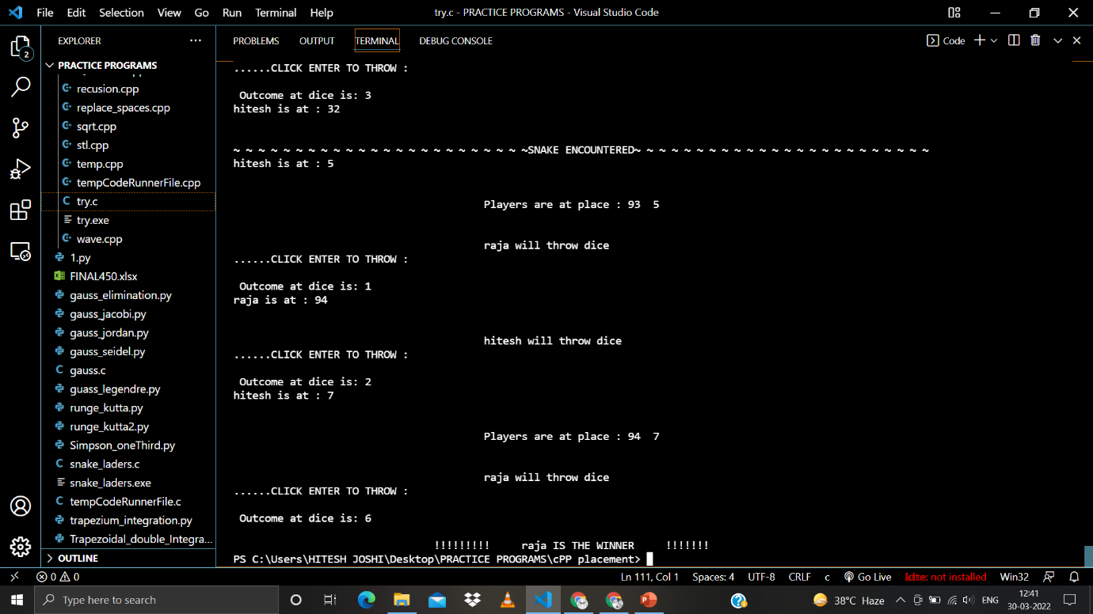

The winner is found and the program terminates